Chapter 6, Solution 42.

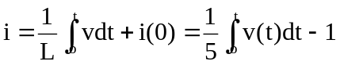
For 0 < t < 1, 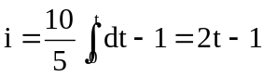 A

For 1 < t < 2, i = 0 + i(1) = 1A

For 2 < t < 3, i = 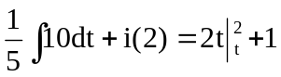
= 2t - 3 A

For 3 < t < 4, i = 0 + i(3) = 3 A

For 4 < t < 5, i = 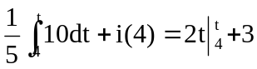
= 2t - 5 A

Thus,
